Seeds, Plant, Flower Test

1) When plants reproduce sexually, a tube grows down the center of the pistil and sperm meets the eggs. This process is known as what?
A) fertilization
B) pollination
C) transpiration
D) regeneration

2) In seed plants, _________________ must occur before fertilization.
A) respiration
B) pollination
C) regeneration
D) germination

3) Which of the following statements best describes the difference between plants and animals?
A) Plants are short-lived.
B) Plants cannot move on their own.
C) Plants live in certain places.
D) Plants are adapted to their environments.

4) Root systems of some plants help to anchor them into the soil. What other function do roots serve in plants?
A) removal of wastes
B) air circulation
C) production of food
D) absorption of water

5) What is dormancy?
A) when plant stops growing because conditions aren’t right for germination
B) roots coming out of a seed
C) new growth on a stem
D) when a flower blooms

6) The female reproductive structure of a flower is the
A) Pistil
B) Stamen
C) Filament
D) Anther

7) The male reproductive structure of the flower is the
A) Style
B) Stigma
C) Pistil
D) Stamen

8) The _______ produces pollen
A) Style
B) Anther
C) Stigma

9) The seed of a flower are formed in the
A) Ovary
B) Stigma
C) Pollen tube
D) Style

10) A seed that sticks is likely transferred by
A) Wind
B) Animals
C) Water

11) What is the benefit of having a seed in a fruit?
A) It protects the seed from storms
B) It encourages animals to eat the seeds and carry them to other locations
C) The seed needs to be in the fruit to grow
D) There is no benefit

Match each tropism to its description
A) Hydrotropism
B) Geotropism
C) Phototropism

12) A root grows down
13) Leaves turn toward the light
14) Roots grow toward the water

Match each seed to its likely method of transfer.

A. 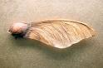 D. 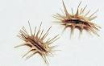

B. 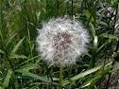 E. 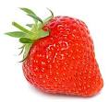

C. 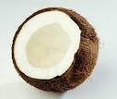
15) Seed that flies from plant
16) Seed that sticks
17) Seed that travels by water
18) Seed that is eaten by animals
19) Seed that travels in wind currents

Match the picture of each part of the plant to its name
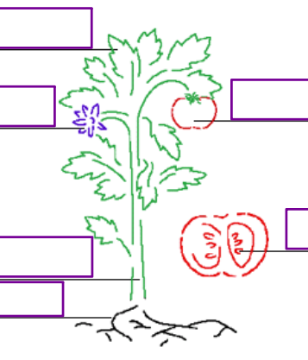
20) Root
21) Fruit
22) Leaf
23) Flower
24) Seed
25) Stem

