Seed Dissection

Purpose:
To dissect a seed, identify the parts, and learn the function of each part.

Part One: Dry Seed Observation

- Look carefully at the lima bean. Examine it with a hands lens.

- Make qualitative observations (describe what you see).
______________________________________________________

______________________________________________________

______________________________________________________

______________________________________________________

- Draw the lima bean.

Part Two: Soaked Seed Observation

- Use a hand lens to examine the soaked lima bean. Compare the soaked bean to the dry bean. What differences do you see?
______________________________________________________

______________________________________________________

- Carefully remove the outside covering of the soaked bean. Gently pull apart the two halves of the seed. Examine each half with a hands lens.

What do you inside the seed? ______________________________________________________

______________________________________________________

______________________________________________________

- Draw what you see inside the bean.

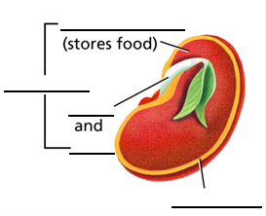

Seed Dissection

Purpose:
To dissect a seed, identify the parts, and learn the function of each part.

Part One: Dry Seed Observation

- Look carefully at the lima bean. Examine it with a hands lens.

- Make qualitative observations (describe what you see).
______________________________________________________

______________________________________________________

______________________________________________________

______________________________________________________

- Draw the lima bean.

Part Two: Soaked Seed Observation

- Use a hand lens to examine the soaked lima bean. Compare the soaked bean to the dry bean. What differences do you see?
______________________________________________________

______________________________________________________

- Carefully remove the outside covering of the soaked bean. Gently pull apart the two halves of the seed. Examine each half with a hands lens.

What do you inside the seed? ______________________________________________________

______________________________________________________

______________________________________________________

- Draw what you see inside the bean.

